**Creation Of An Application For School Management - Admin**

The project aim is to provide real-time knowledge for all the students who have basic knowledge of Salesforce and Looking for a real-time project. This project will also help those professionals who are in cross-technology and want to switch to Salesforce. With the help of this project they will gain knowledge and can include it into their resume as well.

**Creating Developer Org**

**Creating a developer org in salesforce.**

1. Go to [developer.salesforce.com](https://developer.salesforce.com/)
2. Click on sign up.
3. On the sign up form, enter the following details

a. First name & Last name  
b. Email  
c. Role - Developer  
d. Company - College Name  
e. Country - India  
f. Postal Code - pin code  
g. Username- should be a combination of your name and company  
   This need not be an actual email id, you can give anything in the format :   
username@organization.com

Click on sign up after filling these.

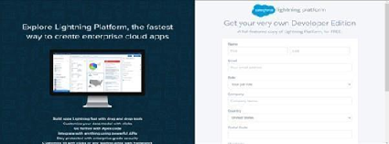

Account Activation

Go to the inbox of the email that you used while signing up. Click on the verify account to activate your account. The email may take 5-10mins, as

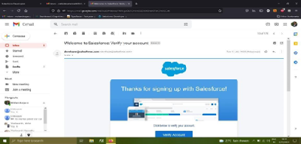

**Login To Your Salesforce Account**

1. Go to salesforce.com and click on login.
2. Enter the username and password that you just created.
3. After login this is the home page which you will see.

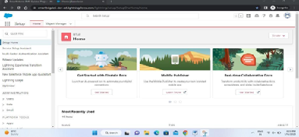

**Salesforce Login**

htttps://login.salesforce.com

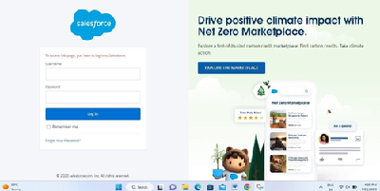

**Creation Of School Object Creation Of Objects For School Management**

For this school management we need to create 3 objects School, Parents and Student. The below steps will assist you in creating those objects.

1. Click on the gear icon and then select Setup.
2. Click on the object manager tab just beside the home tab.
3. After the above steps, have a look on the extreme right you will find a Create Dropdown click on that and select Custom Object.
4. On the Custom Object Definition page, create the object as follows:
5. Label: School
6. Plural Label: Schools
7. Record Name: School Name
8. Check the Allow Reports checkbox
9. Check the Allow Search checkbox
10. Click Save.

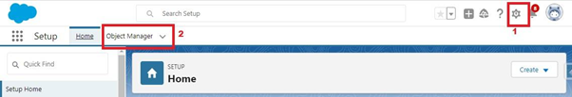

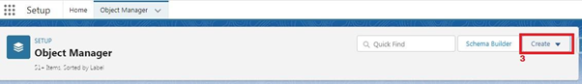

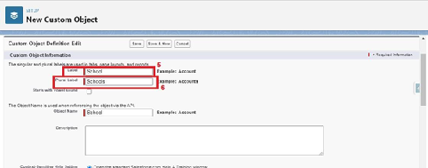

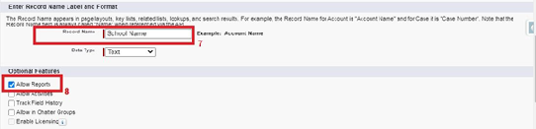

Now create a custom tab. Click the Home tab.

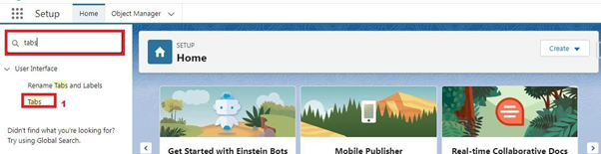

### Create Student Object

1. Click on the gear icon and then select Setup.
2. Click on the object manager tab just beside the home tab
3. After the above steps, have a look on the extreme right you will find a Create Dropdown click on that and select Custom Object.

* On the Custom Object Definition page, create the object as follows:
* Label: Student
* Plural Label: Students
* Record Name: Student Name
* Check the Allow Reports checkbox
* Check the Allow Search checkbox
* Click Save.

Now create a custom tab. Click the Home tab, enter Tabs in Quick Find and select Tabs. Under Custom Object Tabs, click New.

1. For Object, select Students.
2. For Tab Style, select any icon.
3. Leave all defaults as is. Click Next, Next, and Save.

**Create Parent Object**

Click on the gear icon and then select Setup.

1. Click on the object manager tab just beside the home tab.
2. After the above steps, have a look on the extreme right you will find a Create Dropdown click on that and select Custom Object.

* On the Custom Object Definition page, create the object as follows:
* Label: Parent
* Plural Label: Parents
* Record Name: Parent Name
* Check the Allow Reports checkbox
* Check the Allow Search checkbox
* Click Save.

**Now create a custom tab. Click the Home tab, enter Tabs in Quick Find and select Tabs. Under Custom Object Tabs, click New.**

1. For Object, select Parents.
2. For Tab Style, select any icon.
3. Leave all defaults as is. Click Next, Next, and Save.

**Lightning App**

Apps in Salesforce are a group of tabs that help the application function by working together as a unit. It has a name, a logo, and a particular set of tabs. The simplest app usually has just two tabs.

There are two types of app -

1. Standard App: Standard apps come with every occurrence of Salesforce as default. Many features like Sales, Marketing, Community, call center, content, Salesforce Chatter, App Launcher, etc are present in it.
2. Note: The description, Logo, and Label of standard app cannot be altered.
3. Custom Apps: Custom apps are created according to need of user. Custom Apps are made by using standard and custom tabs together.
4. Note: Logos for Custom Apps can be changed.
5. **Create The School Management App**
6. 1. From Setup, enter App Manager in the Quick Find and select App Manager.  
   2. Click New Lightning App.  
   3. Enter School Management as the App Name, then click Next  
   4. Under App Options, leave the default selections and click Next.  
   5. Under Utility Items, leave as is and click Next.  
   6. From Available Items, select Schools, Students, Parents, Reports, and Dashboards and move them to Selected Items. Click Next.  
   7. From Available Profiles, select System Administrator and move it to Selected Profiles.Click Save & Finish.  
     
   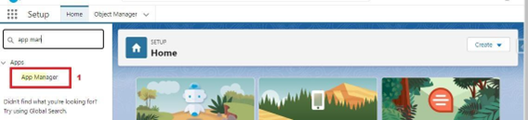  
     
   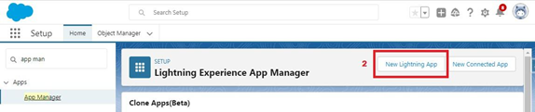  
     
   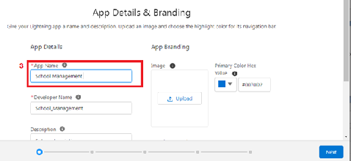  
     
     
   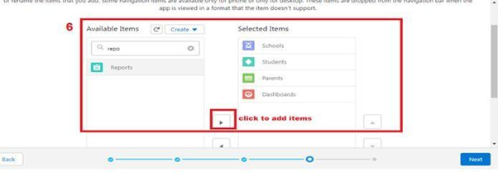  
     
   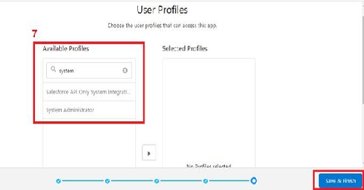  
     
   To verify your changes, click the App Launcher, type School Management and select the School Management app.
7. Note:  
   App Launcher-Displays available apps.  
   App Name-Displays the current selected app.  
   Navigation menu -Displays the tabs available inside the app.
8. **Fields And Relationship**
9. An object relationship in Salesforce is a two-way association between two objects. Relationships are created by creating custom relationship fields on an object. This is done so that when users view records, they can also see and access related data.

### Creation Of Fields For The School Objects

1. Click the gear icon and select Setup. This launches Setup in a new tab.  
2. Click the Object Manager tab next to Home.  
3. Select School.  
4. Select Fields & Relationships from the left navigation  
5. Click New  
6. Select the Text Area as the Data Type, click Next.  
7. For Field Label, enter Address.  
8. Click Next, Next, then Save & New.  
9. Follow steps 1 to 3 and create two more Text type field - District & State.  
10. Create URL type field & give School website as the field label.  
  
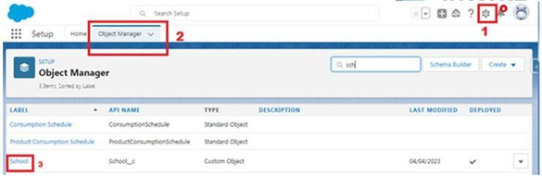  
  
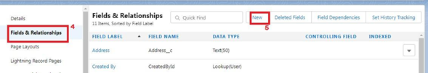  
  
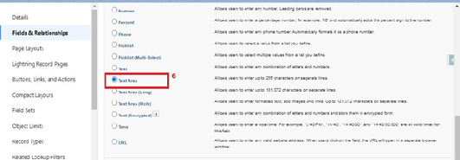  
  
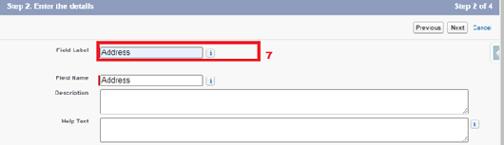  
  
  
Now let's create the other fields and we must choose the data types of the fields carefully. Let's have a look at it.  
  
For example, a phone number is a number field. For that we need to select the phone as data type.  
  
Let’s see this  
  
Note- Follow above steps 1 to 5 to create field and then follow below steps  
       1. Select the Phone as the Data Type, then click Next.  
       2. For Field Label, enter Phone Number.  
       3. Click Next, Next, then Save & New.

**Creation Of Fields For The Student Objects**

Note- Follow above steps 1 to 5 to create field and then follow below steps

1. Select the Phone as the Data Type, then click Next.
2. For Field Label, enter Phone Number.
3. Click Next, Next, then Save & New

**Let's create a master-detail relationship with School object**Note- Follow above steps 1 to 5 to create field and then follow below steps

1. Select Master-Detail Relationship as the Data Type and click Next.
2. For Related to, enter School.
3. Click Next.
4. For Field Label, enter School.
5. Click Next, Next, Next and Save.

**Let’s create a Pick-List field:**  
Note- Follow above steps 1 to 5 to create field and then follow below steps

1. From Setup, click Object Manager and select Student.
2. Click Fields & Relationships, then New.
3. Select Picklist as the Data Type and click Next.
4. For Field Label enter Results.
5. Select Enter values, with each value separated by a new line and enter these values:
6. Pass
7. Fail
8. Click Next, Next, then Save & New

Let’s create a Number field:  
Note- Follow above steps 1 to 5 to create field and then follow below steps

1. Select the Number as the Data Type, then click Next.
2. For Field Label, enter Class.
3. Click Next, Next, then Save & New
4. Follow steps 1 through 3 and create one more number field with Marks as the field labels.

**Let’s create Roll-up summary fields on School Object to calculate the number of students**

1. Click gear icon Select Setup, This launches Setup in a new tab.
2. click Object Manager
3. Select School.
4. Click Fields & Relationships
5. Click New.
6. Select the Roll-up summary field as data type
7. Enter the field label as Number of students
8. Click Next
9. Then select the master object summarized as students
10. Select count as roll-up andthen click Next, Next and save.

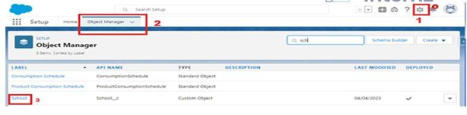

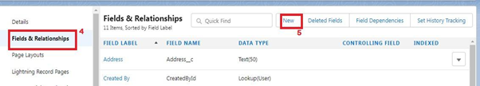

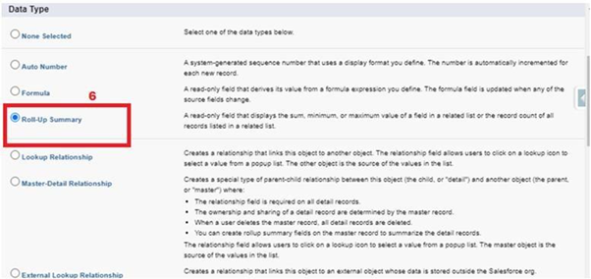

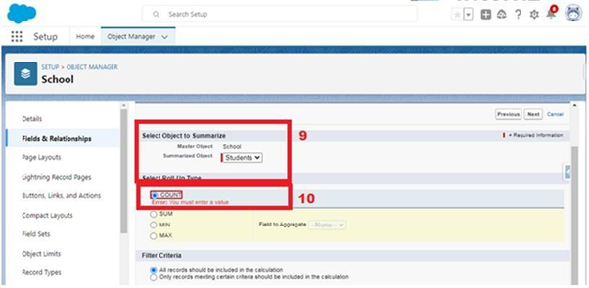

**Create one more rollup summary field-**

* From Setup, click Object Manager and select School.
* Click Fields & Relationships, then New.
* Select the Roll-up summary field as data type
* Enter the field label as Highest Marks
* Click Next
* Then select the master object summarized as students and then select Max as roll-up and then select Marks as field to aggregate.
* click Next, Next and save.

**Creation Of Fields For The Parent Objects**

* Select the Text Area as the Data Type, then click Next.
* For Field Label, enter Parent Address.
* Click Next, Next, then Save & New.
* Select the Phone as the Data Type, then click Next.
* For Field Label, enter Parent Number.
* Click Next, Next, then Save & New

### Profile

A profile is a group/collection of settings and permissions that define what a user can do in salesforce. A profile controls “Object permissions, Field permissions, User permissions, Tab settings, App settings, Apex class access, Visualforce page access, Page layouts, Record Types, Login hours & Login IP ranges

**Creation On Profile**

* From Setup enter Profiles in the Quick Find box
* Select Profiles.
* Click new, From the list of profiles, find Standard User (profile to clone)
* For Profile Name, enter School Profile
* Click Save.
* While still on the School profile page, then click Edit.
* Scroll down to Custom Object Permissions and Give view all access permissions.

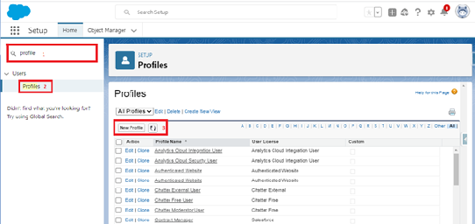

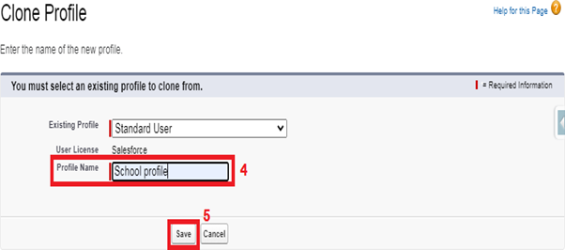

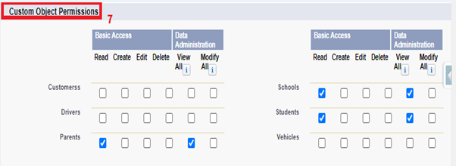

**Users**

A user is anyone who logs in to Salesforce. Users are employees at your company, such as sales reps, managers, and IT specialists, who need access to the company's records. Every user in Salesforce has a user account.

**Creating A User**

1. From Setup, in the Quick Find box, enter Users.
2. Select Users.
3. Click New User.
4. Enter the user’s name Parents and (Your) email address and a unique username in the form of an email address. By default, the username is the same as the email address.
5. Select a User License as salesforce.
6. NOTE- As Salesforce license can only be used by 2 Users at a time in Dev Org, so If you don’t find salesforce license then deactivate a user who has salesforce license or change the license type from Salesforce to any other.
7. Select a profile as a School profile.
8. Check Generate new password and notify the user immediately to have the user’s login name and a temporary password emailed to your email.
9. Similarly follow the above steps and create 2 users as Teachers and principals.

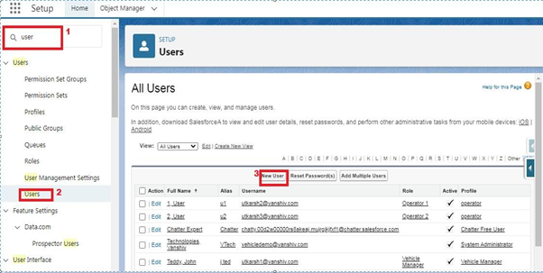

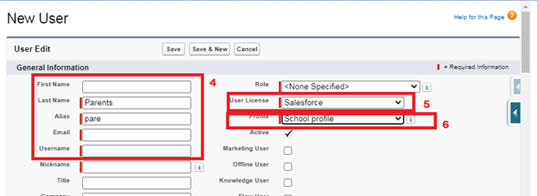

**Permission Sets**

A permission set is a collection of settings and permissions that give users access to various tools and functions. Permission sets extend users' functional access without changing their profiles.

**Permission Sets 2**

1. From Setup, enter Permission Sets in the Quick Find box, then select Permission Sets.
2. Click New.
3. Give the name of the Permission set name as Principal permission and then under the object settings give all permissions for the all 3 custom objects and assign them to the Principal user.

### Permission Sets 2

1. From Setup, enter Permission Sets in the Quick Find box, then select Permission Sets.
2. Click New.
3. Give the name of the Permission set name as Principal permission and then under the object settings give all permissions for the all 3 custom objects and assign them to the Principal user.

1. From Setup, enter Permission Sets in the Quick Find box, then select Permission Sets.
2. Click New.
3. Give the name of the Permission set name as teacher permission.
4. Under the object settings give the view create and edit permissions to all 3 custom objects (By click open the object)
5. Click on manage assignment
6. Click on add assignment.
7. Click on Teacher (user), Next, Assign.

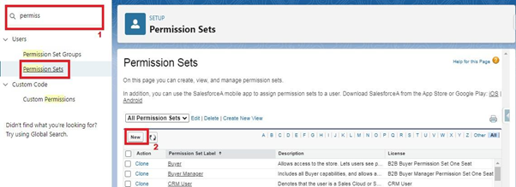

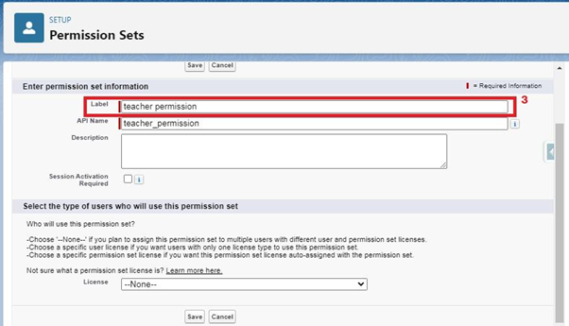

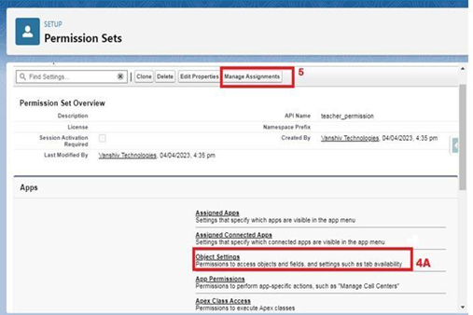

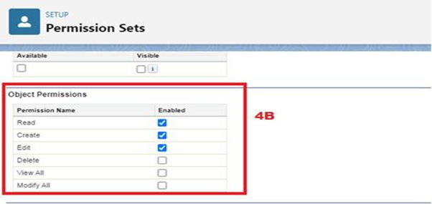

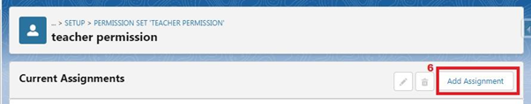

Similarly, follow the above steps for the permission set 2.

**Permission Sets 2**

1. From Setup, enter Permission Sets in the Quick Find box, then select Permission Sets.
2. Click New.
3. Give the name of the Permission set name as Principal permission and then under the object settings give all permissions for the all 3 custom objects and assign them to the Principal user.

### User Adoption

**Create Record (School)**

1. Click on App Launcher on left side of screen.
2. Search School Management App & click on it.
3. Click on Schools tab.
4. Click new button
5. Fill all School record details.
6. Click on Save Button

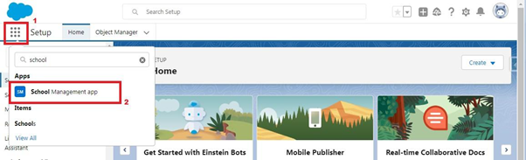

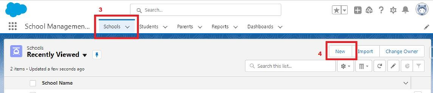

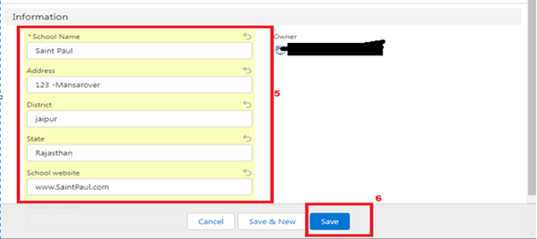

### . View Record (School)

1. Click on App Launcher on left side of screen.
2. Search School Management App & click on it.
3. Click on Schools Tab.
4. Click on any record name. you can see the details of the School.



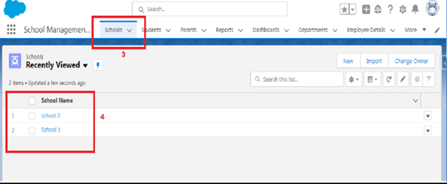

**Delete Record (School)**

1. Click on App Launcher on left side of screen.
2. Search School Management App & click on it.
3. Click on Schools Tab.
4. Click on Arrow at right hand side on that Particular record.
5. Click delete and delete again.



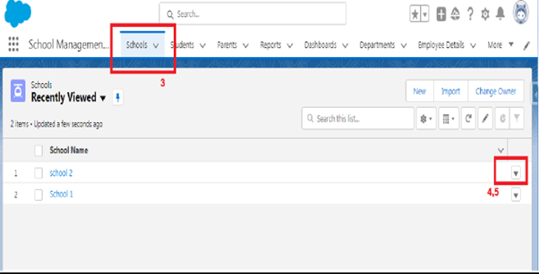

**Reports**

Reports in Salesforce is a list of records that meet a particular criterion which gives an answer to a particular question. These records are displayed as a table that can be filtered or grouped based on any field.  
   
**There are 4 types of report formats in Salesforce:**  
**1.Tabular Reports:**This is the most basic report format. It just displays the row of records in a table with a grand total. While easy to set up they can’t be used to create groups of data or charts and also cannot be used in Dashboards. They are mainly used to generate a simple list or a list with a grand total.  
**2. Summary Reports:**It is the most commonly used type of report. It allows grouping of rows of data, view subtotal, and create charts.  
**3.Matrix Reports:**It is the most complex report format. Matrix report summarizes information in a grid format. It allows records to be grouped by both columns and rows. It can also be used to generate dashboards. Charts can be added to this type of report.  
**4.Joined Reports:**These types of reports let us create different views of data from multiple report types. The data is joined reports are organized in blocks. Each block acts as a subreport with its own fields, columns, sorting, and filtering. They are used to group and show data from multiple report types in different views.  
  
**Report types:**Report type determines which set of records will be available in a report. Every report is based on a particular report type. The report type is selected first when we create a report. Every report type has a primary object and one or more related objects. All these objects must be linked together either directly or indirectly.  
A report type cannot include more than 4 objects.  
Once a report is created its report type cannot be changed.  
  
**There are 2 types of report types:  
       1. Standard Report Type:**Standard Report Types are automatically included with standard objects and also with custom objects where “Allow Reports” is checked.  
  
Standard report types cannot be customized and automatically include standard and custom fields for each object within the report type. Standard report types get created when an object is created, also when a relationship is created.  
  
Note: Standard report types always have inner joins.  
       
**2. Custom Report Types:**Custom report types are reporting templates created to streamline the reporting  
process. Custom Reports are created by an administrator or User with “Manage Custom Report Types” permission. Custom report types are created when standard report types cannot specify which records will be available on reports.  
  
In custom report types we can specify objects which will be available in a particular report. The primary object must have a relationship with other objects present in a report type either directly or indirectly.  
  
**There are 3 types of access levels of folders:  
1. Viewer:**With this access level, users can see the data in a report but cannot make any changes except cloning it into a new report.  
**2. Editor:**With this access level, users can view and modify the reports it contains and can also move them to/from any other folders they have access level as Editor or Manager.  
**3. Manager:**With this access level, users can do everything Viewers & Editors can do, plus they can also control other user’s access levels to this folder. Also, users with Manager Access levels can delete the report.  
  
From this milestone we are going to import the data and create the reports and dashboards for data visualization in the application.

**Create Report**

**Reports:**

1. In School Management App click Reports tab.
2. Click New Report.
3. Select the report type as School with students and parents for the report.
4. Click start report.
5. Customize your report, then save and run
6. Give report name – Schools with Students Report
7. Click Save

* NOTE: In this report you can see your all record of the object you selected for reporting (What you Selects in “Select a report type option”).

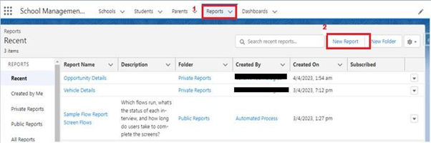

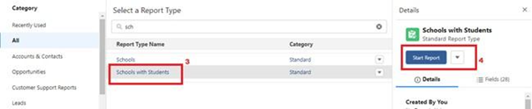

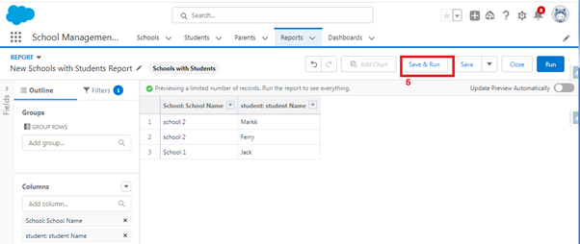

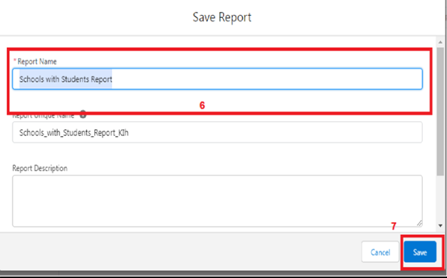

### View Report

1. Click on App Launcher on left side of screen.
2. Search School Management App & click on it.
3. Click on Reports Tab.
4. Click on School with Students report and see records



